**1. Write a query to list the number of jobs available in the employees table.**

select count(distinct job_id) from employees;

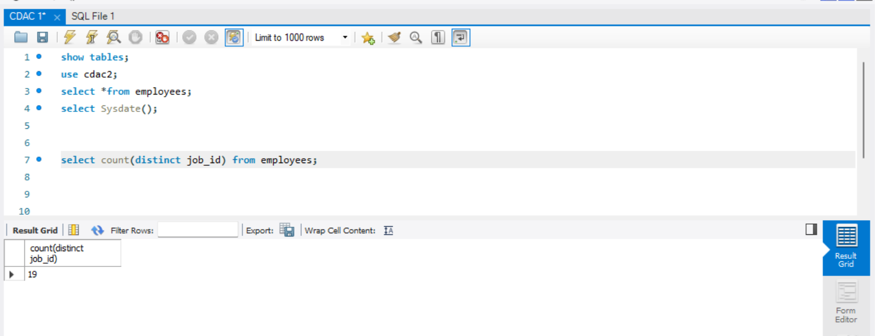

**2. Write a query to get the total salaries payable to employees.**

select sum(salary) as total_salary from employees;  
  
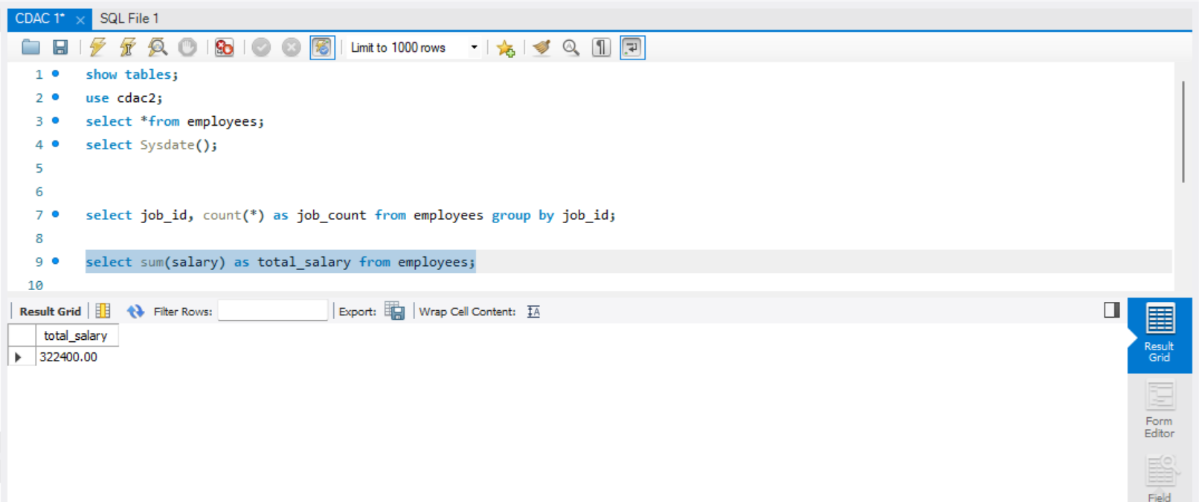

**3. Write a query to get the minimum salary from the employees table.**

select min(salary) as min_salary from employees;

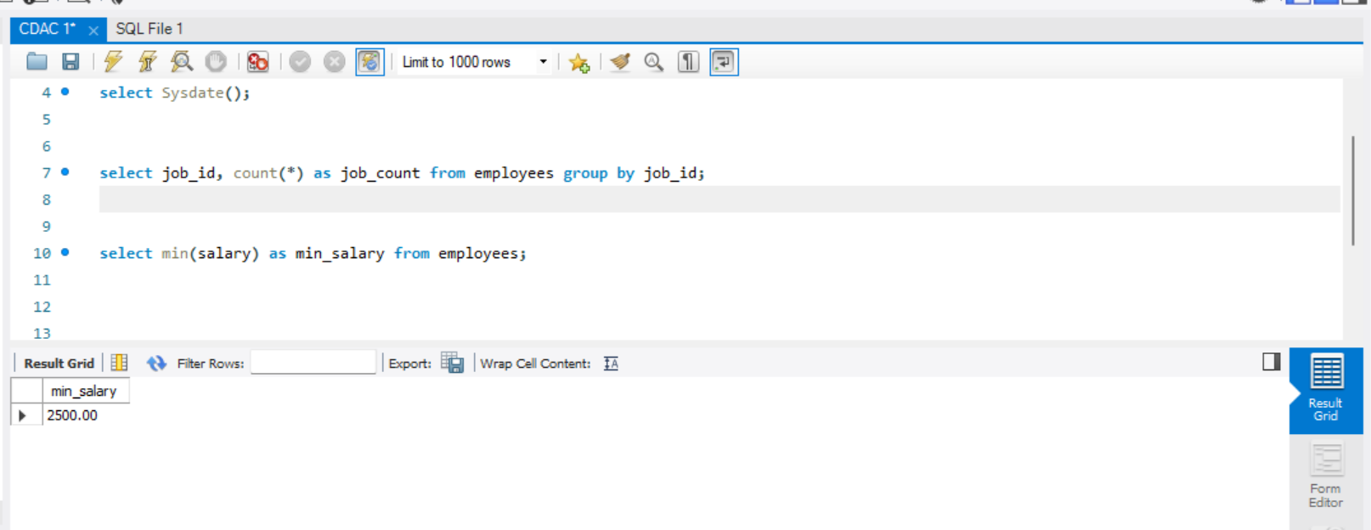

**4. Write a query to get the maximum salary of an employee working as a Programmer.**

select max_salary from jobs where job_title = 'Programmer';

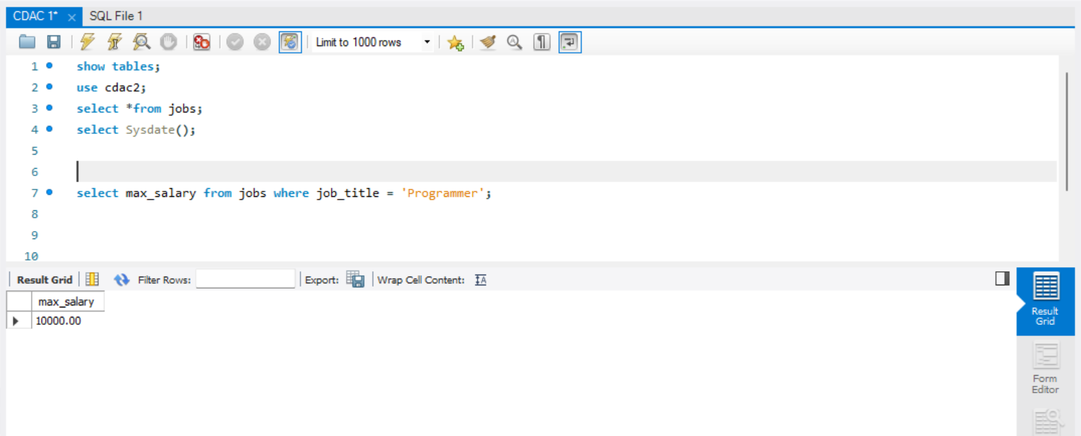

**5. Write a query to get the average salary and number of employees working the department 9.**

select count(employee_id) as total_empoloyees ,avg(salary) as average_salary from employees where department_id=9 group by department_id;

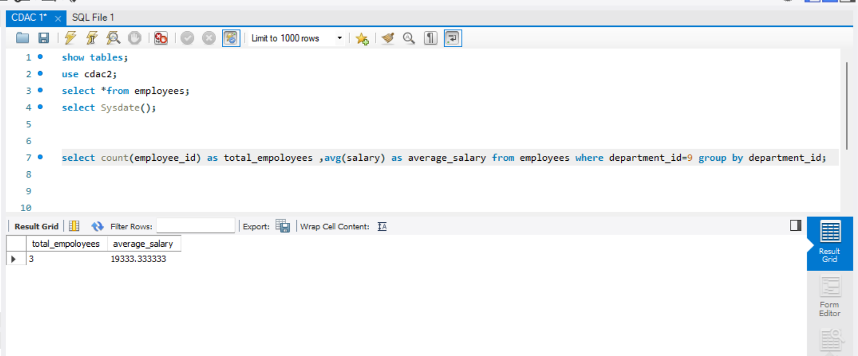

**6. Write a query to get the highest, lowest, sum, and average salary of all employees.**

select max(salary) as max_salary, min(salary) as min_salary, sum(salary) as total_salary, avg(salary) as average_salary from employees;

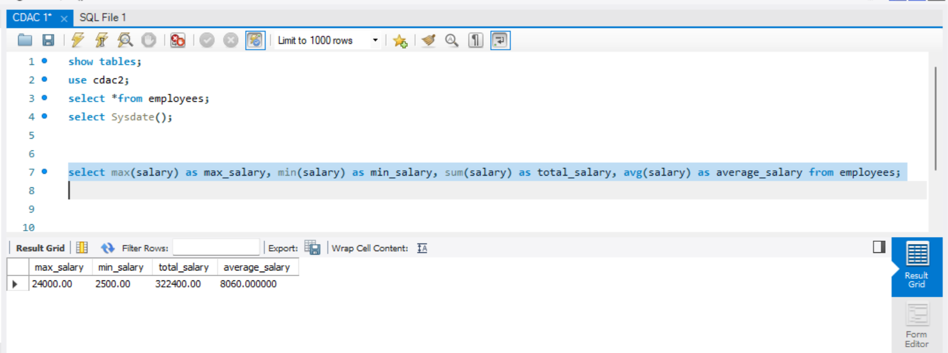

**7. Write a query to get the number of employees with the same job.**

select job_id, count(job_id) from employees group by job_id;

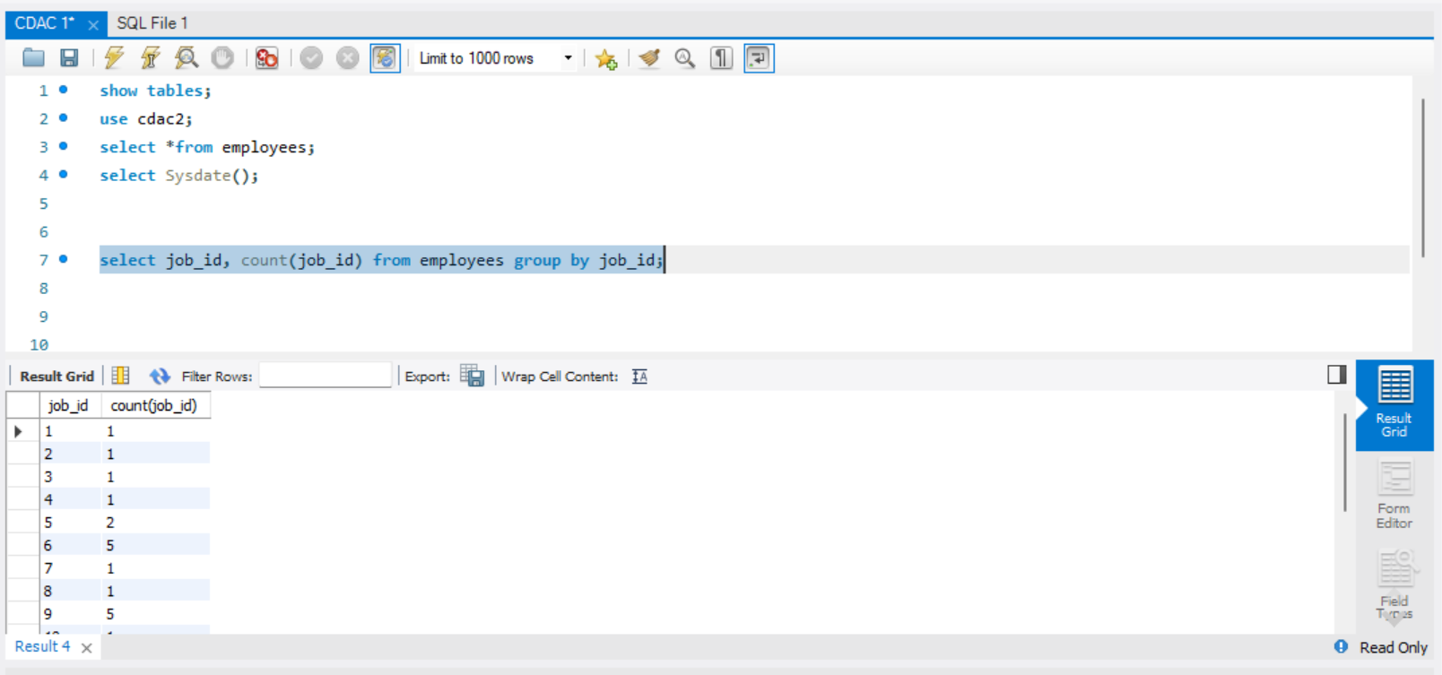

**8. Write a query to get the difference between the highest and lowest salaries.**

select (select max(salary) from employees)-(select min(salary) from employees) as salary_defference;

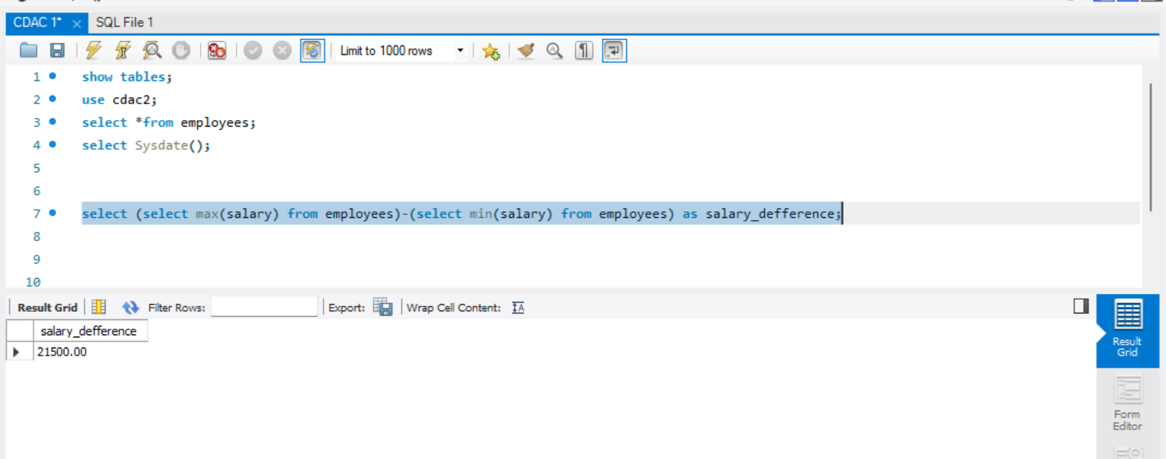

**9. Write a query to find the manager ID and the salary of the lowest-paid employee for that manager.**

select manager_id, min(salary) from employees group by manager_id;  
  
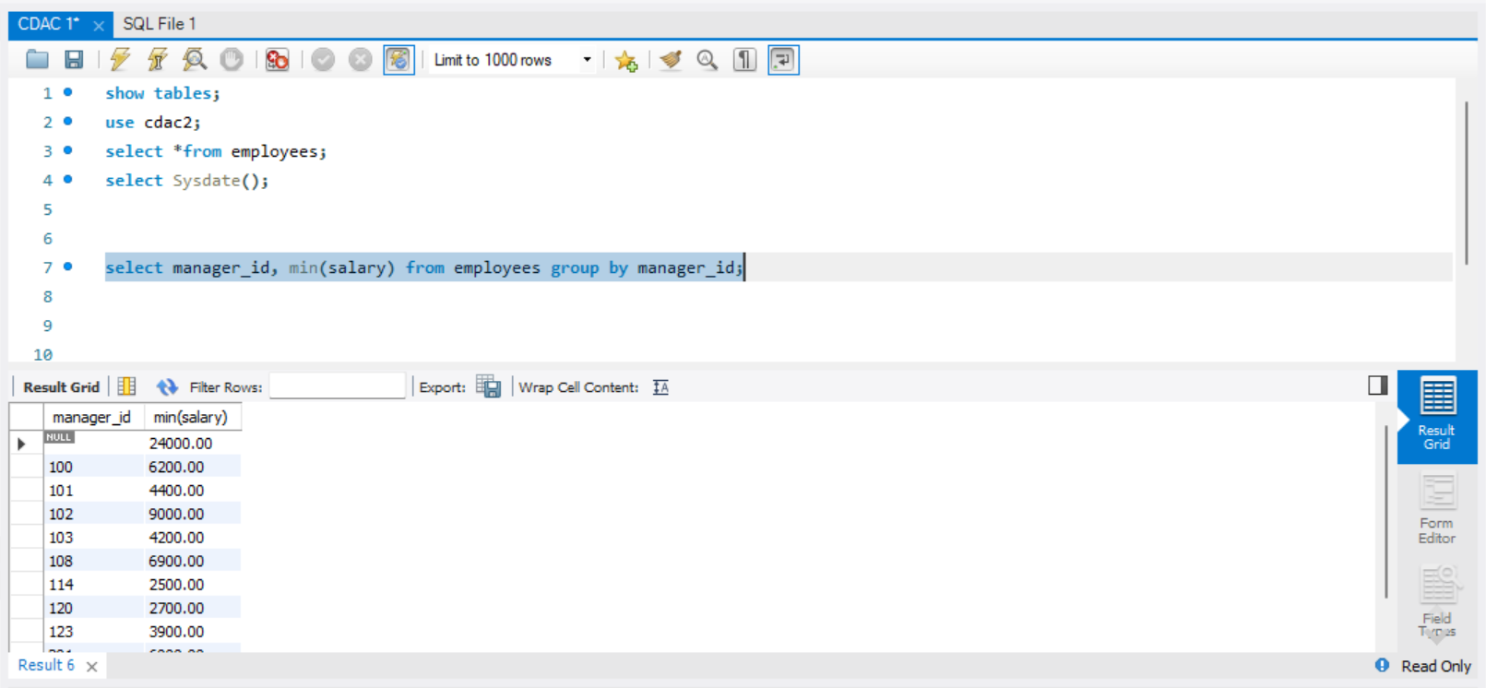

**10. Write a query to get the department ID and the total salary payable in each department.**

select department_id, sum(salary) as total_salary from employees group by department_id;

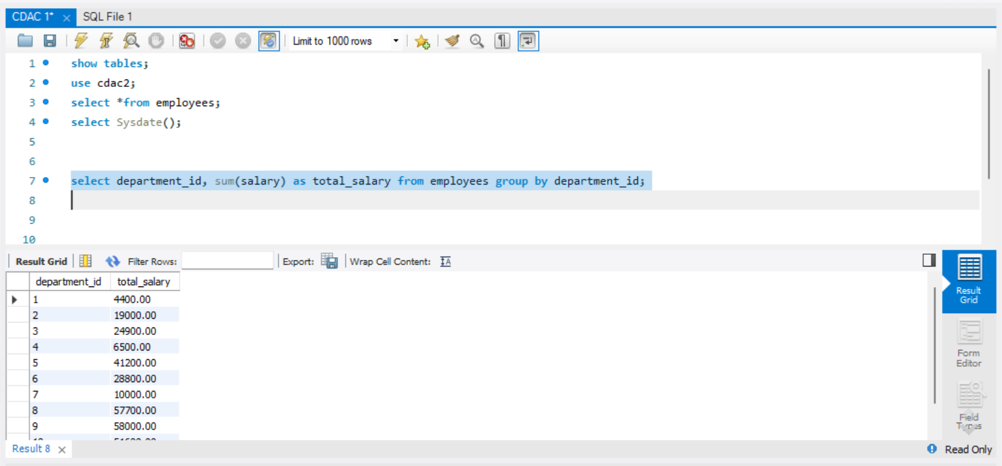

**11. Write a query to get the total salary, maximum, minimum, average salary of employees (job ID wise), for department ID 90 only.**

select job_id, max(salary) as max_salary, min(salary) as min_salary, sum(salary) as total_salary, avg(salary) as average_salary from employees where department_id = 9 group by job_id;

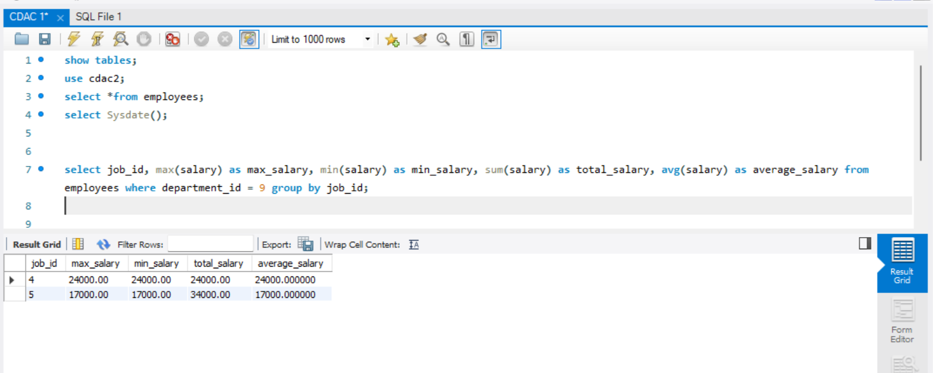

**12.Write a query to get the job ID and maximum salary of the employees where maximum salary is greater than or equal to $4000.**

select job_id, max(salary) as max_salary from employees group by job_id having max_salary >= 4000;

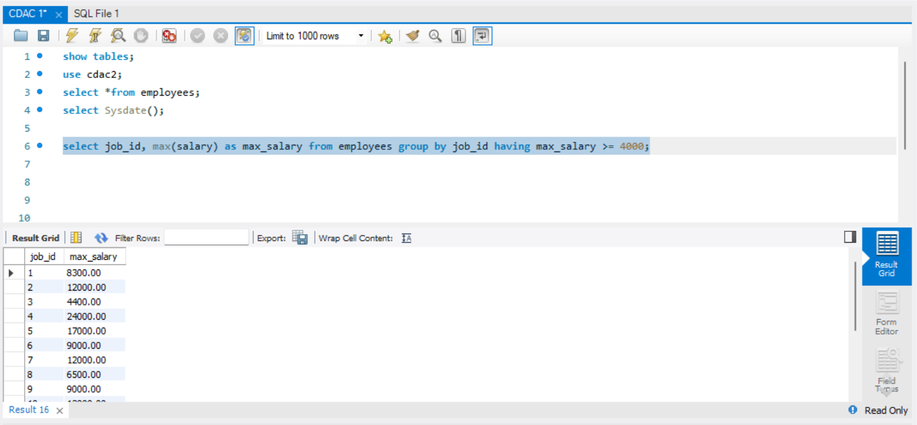

**13.Write a query to get the average salary for all departments employing more than 10 employees.**

select department_id, avg(salary) as avg_salary from employees group by department_id having count(*)>5;  
  
